Easy Read

Privacy

Notice

15th November 2022

Who are we?

We, at Downend Health Group, North Street, Downend, Bristol, BS16 5SG are Data Controller of your information.



This means we are responsible for collecting, storing, and handling your personal and healthcare information when you register with us as a patient.

There may be times where we also process your information

This means we use your information for a particular purpose, we may also be called a Data Processor.



We are registered with **the Information Commissioners Office (ICO)** to use information about the people we work with under the Data Protection Act 2018

Our registration number is ZA427576

What information do we collect about you?

Your name

Your address, where you live



Your phone number

Who is your family, who looks after you



Your date of birth

What else ask from you?

Your marital status

Your job if you have one



Your email address if you have one

Your religion if you have one



What you like to be called

Where you were born



How do we keep your information?



Your records are stored on an electronic database system and are protected.

Your records may be stored on paper file, also kept safe.



All staff at the practice must keep your information safe.

Some information we keep about you may be sensitive



Your patient health records are sensitive

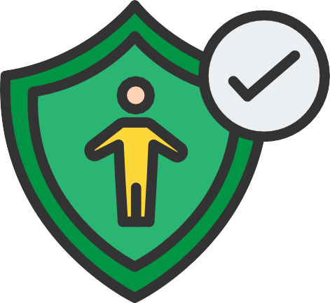

Any safeguards that you have to protect you

How do we use your information?



To give to other people who are treating you.



To make things better for you at your medical practice.



To share with people organising your care for medical research purpose.

To follow the law, we sometimes need to share your information if...



If the policerequire information as part of a criminal investigation



Information might be required by law due to fraud



If there is a court order

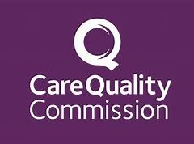

If the Care Quality Commission CQCrequire it during an inspection

To comply with the law, we must...



Follow the Data and the Common Law Duty of Confidentiality.



Keep your records safe.



Only authorised members of staff can access your records and are part of caring for you.

Keep your records confidential and secure at all times.

Why do we share information and under what conditions?



To tell you how personal information will be used



We need to have a legal reason for using your information without asking you first



Sometimes your information will be used using your name without your consent.

Who do we share information with?

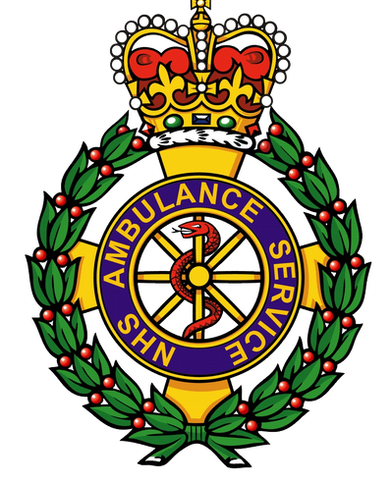

Ambulance Services

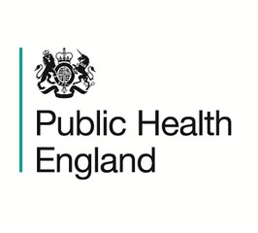

Public Health England and other NHS Trusts



General practitioners

(GPs)

Who else, do we share information with?

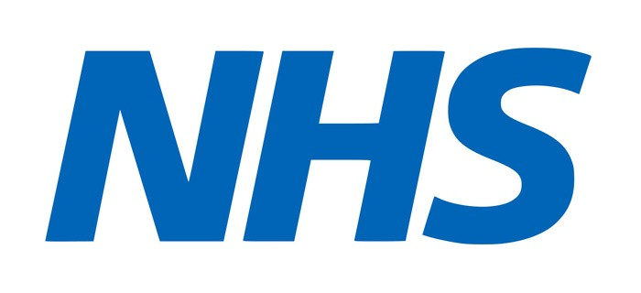

NHS England



Social Services or private care homes to help them give you the best support.



Primary Care Agencies

What does the National data opt- out mean for you?



Information about you is collected when using our services



Your collected information can be used and provided to other organizations

Collected information will improve the quality and standards of care provided to you and others



You have choice whether your confidential information can be used



Use of your confidential patient information about your health and care is only when allowed by law.



Anonymised data is used for research and planning so that you cannot be identified

If you choose to opt out, your confidential information will only be used to support your care.

What are your rights?

Under UK law The Data Protection Act and GDPR you can...



Tell us not to share your information if you really do not want us to, unless if it is required by law



Ask us to give you a copy of your records. This is caller a Rights of Access request

Ask us to change any information if it is wrong or incorrect

Ask for copies of your documents to other organisations if requested

If you are unhappy, who do you talk to?

You can speak to our **Data Protection Officer**:

**Liberty Apted**

Avon Local Medical Committee, 14a High Street, Staple Hill, Bristol, BS16 5HP

Direct Line: **0117 4038446**

[www.avonlmc.co.uk](http://www.avonlmc.co.uk/)

OR

**The Information Commissioners Office**

Call the helpline on **0303 123 1113**

https://ico.org.uk/make-a-complaint/

Privacy Notice next review: November 2023