EASY READ NEW PATIENT HEALTH QUESTIONNAIRE

Please speak to our reception team if you would like help with this form. Please use a black pen.

Your first name:

Your last name:

Your date of birth:

Day Month Year

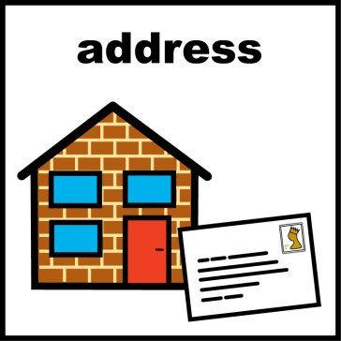
Your address:

Your postcode:

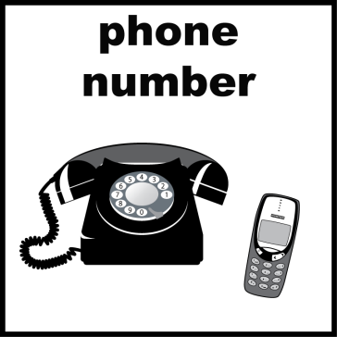
Your home
phone number:

Your mobile
phone number:

Do you have a religion?

Yes No

What is your religion?

How can we contact you? Please tick any boxes that apply.

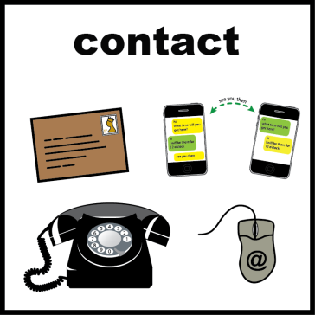
Phone: Yes No

Email: Yes No

Text: Yes No

Letter: Yes No

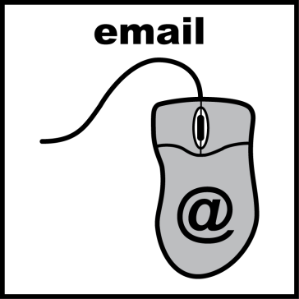
Please tell us your email address:

What is your ethnicity:

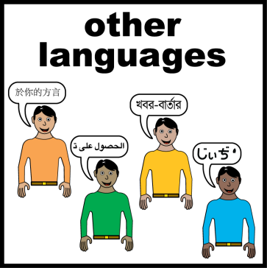
Do you need an interpreter?

Yes No

If yes, what is your language choice?

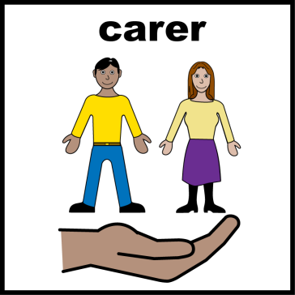
Do you have a carer or keyworker?

Yes No

What is their first name:

What is their last name:

What is their phone number:

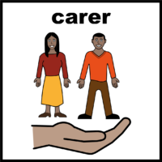
Do you care for someone that has a long-term illness?

Yes No

Please tell us the name of the person you care for:

First Name

Last Name

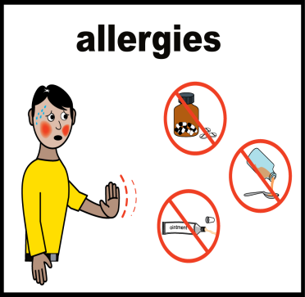
Do you have any allergies?

Yes No

What are you allergic to:

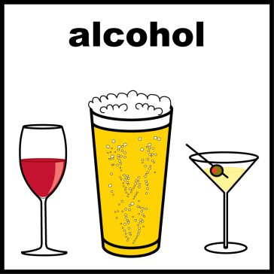
Do you drink alcohol?

Yes No

How many glasses each week

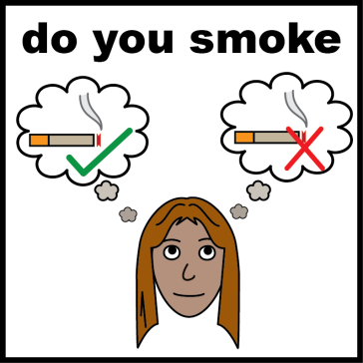
Do you smoke?

Yes No

How many cigarettes do you smoke each day?

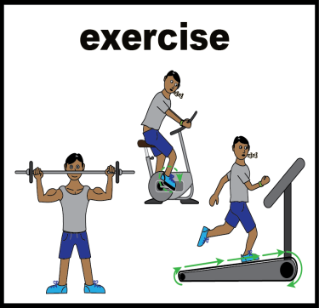
How many hours do you exercise each week:

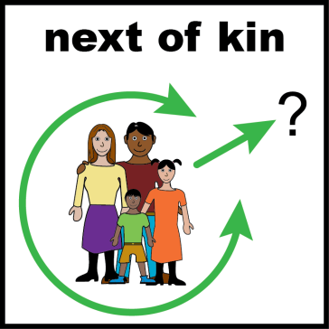
What is the first name of your next of kin:

What is the last name of your next of kin

What is their telephone number:

What is their relationship to you:

What is their date of birth:

What is their address:

Do you agree to share your medical information
with them?

Yes No

If you agree, we need you to send a letter telling
us that this is ok. If you need help, please speak
with the receptionist.

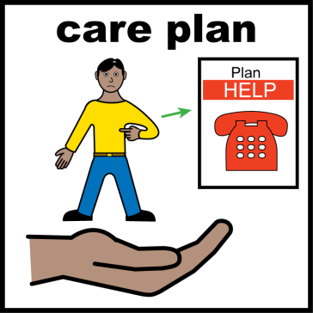
Do you have a health action plan:

Yes No

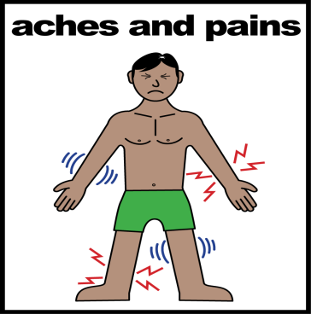
Do you have any long-term illnesses?

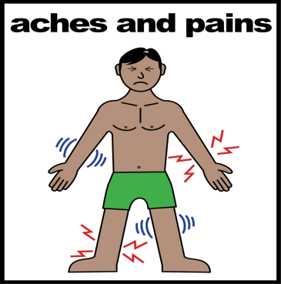
Does anyone in your family have a long term
illness?

Yes No

Please give us a bit more information if you ticked
the yes box.

Who is ill?

What is the illness?

Please answer the following questions. We have equipment in the waiting room for you to use. Please ask the receptionist if you would like any help.

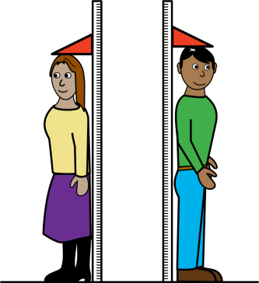
Please tell us how tall you are in centimetres.

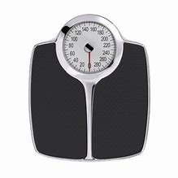
Please tell us your weight in kg.

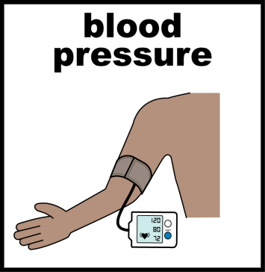
Please tell us your blood pressure reading.

DIA SYS PUL

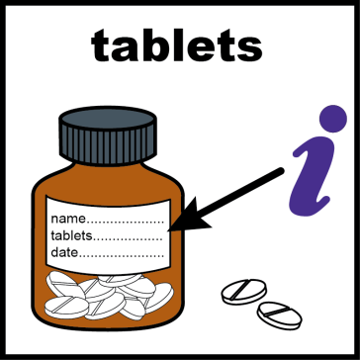
Please tell us if you take any medication.

We will send your prescription to a pharmacy

Please tell us the name of pharmacy you would
like to collect your medication from.

Please inform us if you have any additional information and/or communication needs. This will help us better communicate with you.

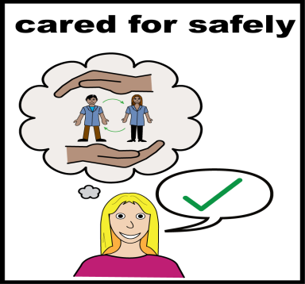
We will record your needs on your medical
notes.

We may share this information with other care
providers.

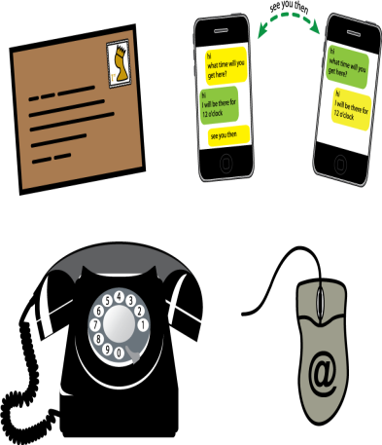
Please let us know if your choice of
communication changes.

It is important that we know how to contact you.

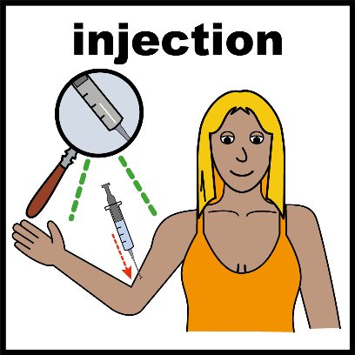
If you are over 18 and new to the United Kingdom,
please complete the form below. Please ask the
receptionist if you would like some help.

AGE | HAVE YOU HAD THIS VACCINE? | WHAT DATE DID YOU RECEIVE IT?
If you are aged 65 years or older | Pneumococcal (PPV) Vaccine  Also known as pneumonia
If you are 65 years or older | Annual Influenza Vaccine  Also known as Flu | This year’s date only
If you are 70 years | Shingles (Herpes Zoster) Vaccine  Single dose
Shingles (Herpes Zoster) Vaccine
(patients with weakened immune system)
1st Dose
Shingles (Herpes Zoster) Vaccine
(patients with weakened immune system)
2nd Dose
Please sign your name in the box below.

Signature.

Date.

